**OTJ - OSMTJ MONTHLY DEVOTIONAL**

**June 2024**

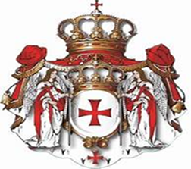



**OPENING PRAYER**

In the name of the Father and of the Son and of the Holy Spirit. *Amen.*

Dear God, we come to You today confessing that we frequently suffer with fear and desperation

over things that we cannot control. We turn to You only as a last resort, forgetting that You

have invited us to rely on You and ask for anything we need. Our human nature becomes our

worst enemy and we only add to our pain and suffering by trying to do things on our own.

Help us to have the faith to remember that You are our friend and savior, always ready

to love us and meet our every need. We ask this in the name of Your Son, Jesus Christ. *Amen*.

# READINGS FOR THE WEEK OF JUNE 30, 2024

# Psalm 30 (NIV)

I will exalt you, Lord, for you lifted me out of the depths and did not let my enemies gloat over me.

Lord my God, I called to you for help, and you healed me. You, Lord, brought me up from the realm of the dead; you spared me from going down to the pit. Sing the praises of the Lord, you his faithful people; praise his holy name. For his anger lasts only a moment, but his favor lasts a lifetime; weeping may stay for the night, but rejoicing comes in the morning. When I felt secure, I said, “I will never be shaken.” Lord, when you favored me, you made my royal mountain stand firm; but when you hid your face, I was dismayed. To you, Lord, I called; to the Lord I cried for mercy: “What is gained if I am silenced, if I go down to the pit? Will the dust praise you? Will it proclaim your faithfulness? Hear, Lord, and be merciful to me; Lord, be my help.” You turned my wailing into dancing; you removed my sackcloth and clothed me with joy, that my heart may sing your praises and not be silent. Lord my God, I will praise you forever.

Glory be to the Father, and to the Son, and to the Holy Spirit;

as it was in the beginning, is now, and will be forever. *Amen.*

**The Gospel:Mark 5:21-43**

When Jesus had again crossed over by boat to the other side of the lake, a large crowd gathered around him while he was by the lake. Then one of the synagogue leaders, named Jairus, came, and when he saw Jesus, he fell at his feet. He pleaded earnestly with him, “My little daughter is dying. Please come and put your hands on her so that she will be healed and live.” So Jesus went with him. A large crowd followed and pressed around him. And a woman was there who had been subject to bleeding for twelve years. She had suffered a great deal under the care of many doctors and had spent all she had, yet instead of getting better she grew worse. When she heard about Jesus, she came up behind him in the crowd and touched his cloak, because she thought, “If I just touch his clothes, I will be healed.” Immediately her bleeding stopped, and she felt in her body that she was freed from her suffering. At once Jesus realized that power had gone out from him. He turned around in the crowd, stopped and asked, “Who touched my clothes?” “You see the people crowding against you,” his disciples answered, “and yet you can ask, ‘Who touched me?’ ” But Jesus kept looking around to see who had done it. Then the woman, knowing what had happened to her, came and fell at his feet and, trembling with fear, told him the whole truth. He said to her, “Daughter, your faith has healed you. Go in peace and be freed from your suffering”. While Jesus was still speaking, some people came from the house of Jairus, the synagogue leader. “Your daughter is dead,” they said. “Why bother the teacher anymore?” Overhearing what they said, Jesus told him, “Don’t be afraid; just believe.” He did not let anyone follow him except Peter, James and John the brother of James. When they came to the home of the synagogue leader, Jesus saw a commotion, with people crying and wailing loudly. He went in and said to them, “Why all this commotion and wailing? The child is not dead but asleep.” But they laughed at him. After he put them all out, he took the child’s father and mother and the disciples who were with him and went in where the child was. He took her by the hand and said to her, “Talitha koum!” (which means “Little girl, I say to you, get up!”). Immediately the girl stood up and began to walk around (she was twelve years old). At this they were completely astonished. He gave strict orders not to let anyone know about this and told them to give her something to eat.

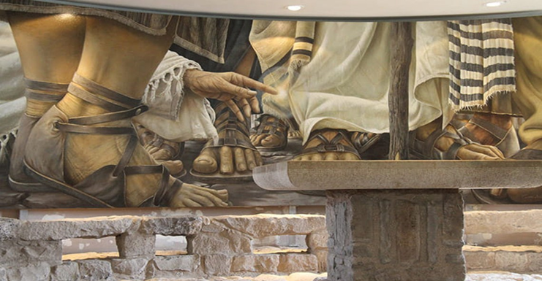

The Encounter between Jesus and the hemorrhaging woman by Daniel Cariola.

Oil on canvas. 1998. The Encounter Chapel, Magdala

**MEDITATION**

**A Bleeding Woman ~ Turning Fear into Faith**

(Nancy Lucenay -March 18, 2020)

How can we turn our fear into faith? Two people found their answer in Jesus: A desperate father whose worst nightmare was coming true and a bleeding woman who had endured a 12-year nightmare of self-quarantine. Both needed faith as they struggled to manage their fear. In them, we find a contrast between faith that had to act despite fear and faith that had to wait despite fear.

**For Jairus, Twelve Years Wasn’t Long Enough**

As soon as Jesus stepped off the boat, Jairus met him. Jairus’ honorable position as a synagogue leader hadn’t protected him from the fear and pain of watching his precious daughter suffer. She was only 12 years old, much too young to die, but Jairus knew her death was imminent. When Jesus agreed to accompany him, hope overrode the fear in Jairus’ heart. But then a woman interrupted their mission, and his fear returned like a flock of vultures.

**For the Bleeding Woman, Twelve Years Was Too Long**

Jewish purity codes required a woman experiencing her monthly uncleanness to refrain from her regular duties. She transmitted her uncleanness to everyone and everything she touched. Although she might appreciate a one-week vacation every month, no one wanted permanent estrangement. But the desperate woman had endured her condition, not just one week but 624 weeks! Overwhelming shame and isolation defined the bleeding woman’s life. She was bankrupt in every area—physical, financial, spiritual, social, emotional, and psychological. Her dishonor was as wide-reaching as Jairus’ honor.

**The Bleeding Woman Risked Hope**

Despite her pounding heart, the woman pushed past her fear of rejection and disappointment. Creeping through the crowd, she stretched her hand to reach the tassels on Jesus’ prayer shawl. Despite her fear, the bleeding woman acted on her faith in Jesus’ power to heal. When she touched the tassels, her greatest hope and greatest fear embraced. She had risked contaminating Jesus and everyone else with her uncleanness. However, his power to cleanse was more potent than hers to contaminate. She experienced healing, but Jesus shattered her hope of invisibility. His question made her heart sink as shame replaced the joy of healing. Since Jesus insisted, she identified herself, fearing the crowd’s anger and his. Why did he force her to confess? Jesus wanted to give the bleeding woman more than physical healing. He yearned to remove her shame and restore her honor in the community. His response shocked her:

Daughter, your faith has healed [saved] you. Go in peace and be freed from your suffering.

The Greek word for saved refers to both physical and spiritual healing. She was the only person Jesus called Daughter, and he welcomed her into his shalom.

**A Deadly Delay**

As Jairus waited, messengers came with the dreaded news—his daughter was dead. Grief flooded his heart. But two daughters had needed Jesus’ touch, and both were precious. Jesus called on Jairus to exercise faith. Don’t be afraid; just believe. Faith is a choice to believe, despite doubts and questions. Jairus listened to his faith rather than his fear. And again, Jesus showed his power when he raised Jairus’ daughter from the dead.

**Does Faith Heal?**

According to rabbinic tradition, the water of the Red Sea didn’t divide for the Israelites until they were in up to their nostrils. Faith does not wait to see if the waters will split before stepping out. It steps out, trusting God to do what’s needed. Belief isn’t enough; faith requires risk. Unless it leads to action, faith is only an idea.

Faith doesn’t heal; God heals. Likewise, prayer doesn’t work; God works. Faith and prayer open the door to God’s power, enabling him to do what he wants.

**How to Turn Fear into Faith**

We know the dog we feed the most will win the dogfight. So we must feed our faith, not our fear. Feed it with:

Meditation on God’s Word, especially passages that focus on his character

(Exodus 34:6-7a; Isaiah 40:28-31)

Memorization of God’s promises (Isaiah 43:1-7; John 16:33)

Memories of God’s past faithfulness (Deuteronomy 4:9; 1 Chronicles 16:12)

Mindfulness of God’s presence (Psalms 46 and 139)

Mind control, taking every thought captive to make it obedient to Christ

(2 Corinthians 10:5; Philippians 4:6-8)

Faith means relinquishing control, trusting God to do what’s right when it’s right. Which dog are we feeding—fear or faith?

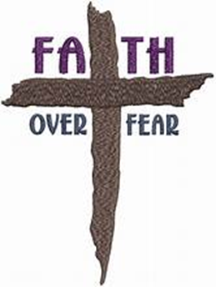

**CHRISTIAN POEM**

**Let Me Touch His Garment**

([Joseph J. Breunig III](https://www.amazon.com/Joseph-J-Breunig-III/e/B004FJXZ72?ref=sr_ntt_srch_lnk_1&qid=1714873681&sr=8-1))

Many doctors had failed to heal her;

her wealth was gone; unable to cope,

seemingly having no options left, she…

faced the idea of being bereft of hope.

A difficult issue of continual bleeding,

had bothered this woman for twelve years;

purposely maneuvering through the crowd,

she hoped to meet Christ and draw near.

“If only, I could physically touch Him,

my personal need can be forever met.”

Summoning the last of her inner strength,

she pressed onward without any regret.

Her health was dramatically worsening

and drastic action was now required;

since Christ was visibly close by,

perhaps healing she urgently desired

would become available to her this day.

Moving boldly with faith towards Him,

silently reaching out for his garment

with her weakened, slender limb…

she briefly caressed the hem of His robe.

And suddenly- her discomfort was gone!

Without warning, virtue leapt out of Him;

and now He wanted a face to gaze upon.

To everyone’s astonishment, He stopped;

then came the simple, unexpected question:

“Who touched me?” He patiently inquired.

Initially, there was apparent confusion,

from not knowing who, He was addressing.

Scared and embarrassed, she fell face down

at His feet, ready to weep and apologize.

“Rise up my daughter, from the dusty ground;

tell me your life’s story of suffering;

since your faith was successfully released,

My strength has cured you of your agony;

return home with my blessings and peace.”

**THE LORD’S PRAYER**

Our Father, who art in heaven, hallowed be thy Name. Thy kingdom come,

thy will be done, on earth as it is in heaven. Give us this day our daily bread

and forgive us our trespasses, as we forgive those who trespass against us.

And lead us not into temptation but deliver us from evil. For thine

is the kingdom, and the power, and the glory, for ever and ever. Amen

**BLESSING**

**A Prayer of Faith and Action**

(Father Goyo Hidalgo)

Lord, Help me

Be prepared, but not anxious.

Be aware, but not desperate.

Be Vigilant, but not in fear.

Be Joyful, but not clueless.

Be Faithful, but not careless.

Lord, be my hope and my strength.

*Amen*

*Respectfully submitted by Lori Toro*

*Verger, Chaplain Corp, OTJ*

*Translation assistance by Archbishop Raul E. Toro, Jr*

*Chaplain Corp, OTJ*